Simple Unit Converter
Objective:
The Conversion between different units of measurement for the same quantity.
Complexity Level:
- Easy
Business Scenario:
- Conversion of units is the conversion between different units of measurement for the same quantity, typically through multiplicative conversion factors.
- The units program converts quantities expressed in various systems of measurement to their equivalents in other systems of measurement.
- The operation is simple write the units that you want to convert from and the units you want to convert to.
Data Set:
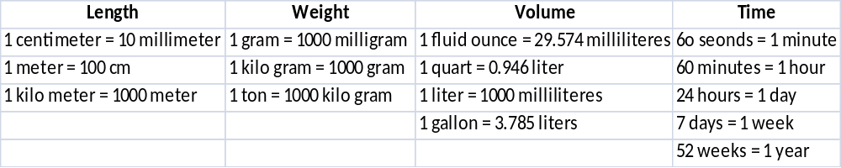
Problem Statement:
- Write an algorithm to find the 10 meters equivalent values in centimeters units.
- Write an algorithm to find the 2 tons equivalent values in kilograms units.
- Write an algorithm to find the 5 gallons equivalent values in liters units.
- Write an algorithm to find the 21 days equivalent values in weeks.
Expectation Outcome:
Draw the flow chart to convert the different units of measurement for the same quantity.
Tools:
- Open office for designing the flow chart.

Reference URL:
- Jobs (September 14, 2012). "The astronomical unit gets fixed: Nature News & Comment". Nature.com. doi:10.1038/nature.2012.11416. Retrieved August 31, 2013.
- "NIST Reference on Constants, Units, and Uncertainty."(2010). National Institute of Standards and Technology. Retrieved October 17, 2014.
- U.S. National Institute of Standards and Technology Handbook 44 Appendix C - General Tables of Units of Measurement 2013 Edition.

